Architecture Document
Application
Microservices
In the microservice-based approach, the system is decomposed into independently deployable services, each responsible for a specific business capability.
Key Microservices:
- Data Ingestion Service: Handles incoming pollution and meteorological data
- Preprocessing Service: Performs feature transformation and normalization
- Prediction Service: Hosts trained ML and Transformer models
- Noise Classification Service: Performs noise risk categorization
- API Gateway: Manages client requests and routes them to appropriate services
Benefits:
- Independent scaling of compute-intensive services (e.g., transformer inference)
- Fault isolation and easier maintenance
- Suitable for large-scale smart city deployments
Use Case:
Best suited for enterprise-grade systems requiring high availability and continuous model updates.

Event-Driven Architecture
In an event-driven setup, system components communicate asynchronously through events, enabling real-time responsiveness and loose coupling.
Event Flow:
- New pollution data arrival triggers a Data Ingested event
- Preprocessing completion triggers a Features Ready event
- Prediction completion triggers a Prediction Generated event
- Alerts are generated for high-risk noise or AQI events
Event Brokers:
- Kafka / RabbitMQ / cloud-based messaging services
Benefits:
- Real-time pollution monitoring and alerting
- Efficient handling of bursty data streams
- Improved system responsiveness for critical pollution events
Use Case:
Ideal for real-time alert systems and continuous environmental monitoring.
Serverless Architecture
In the serverless approach, the system leverages cloud-managed functions to execute prediction logic on demand.
Components:
- Serverless Functions for preprocessing and inference
- Managed storage for models and datasets
- API Gateway for request handling

Database
ER Diagram
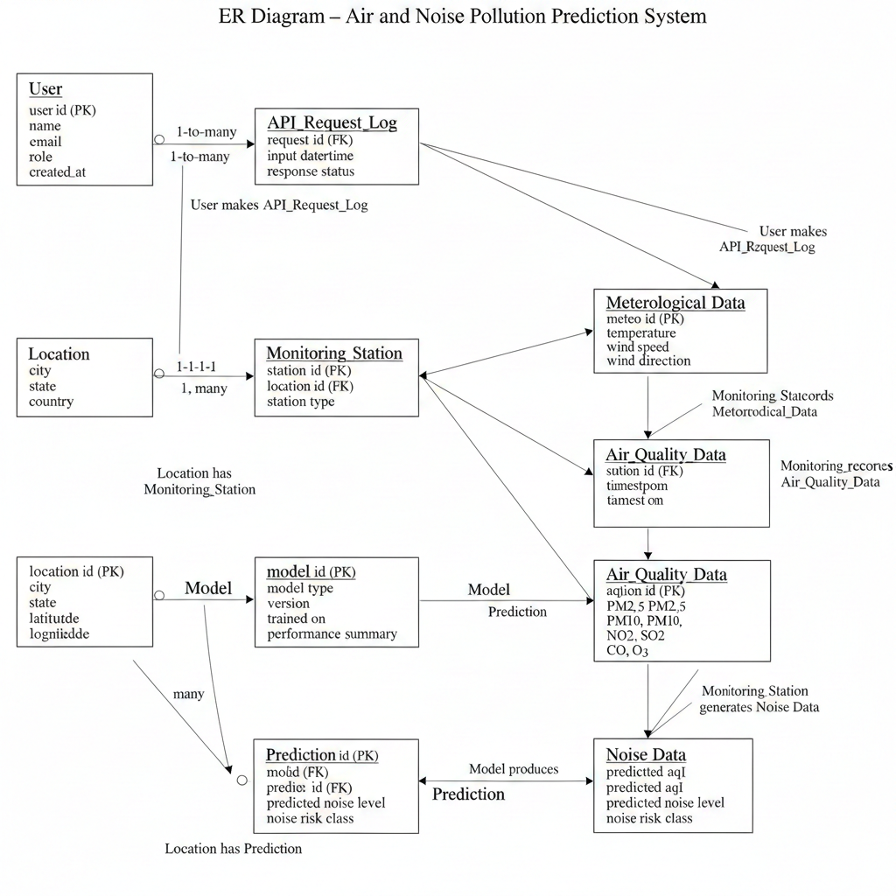

Schema design
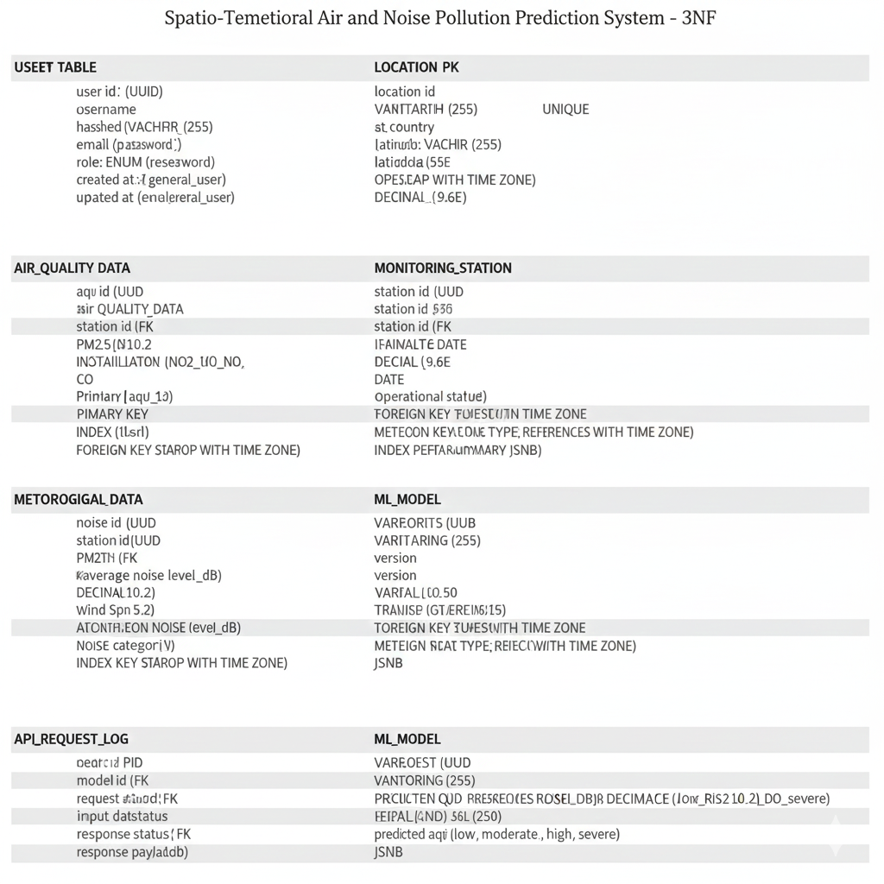

Low Level Architecture Diagram
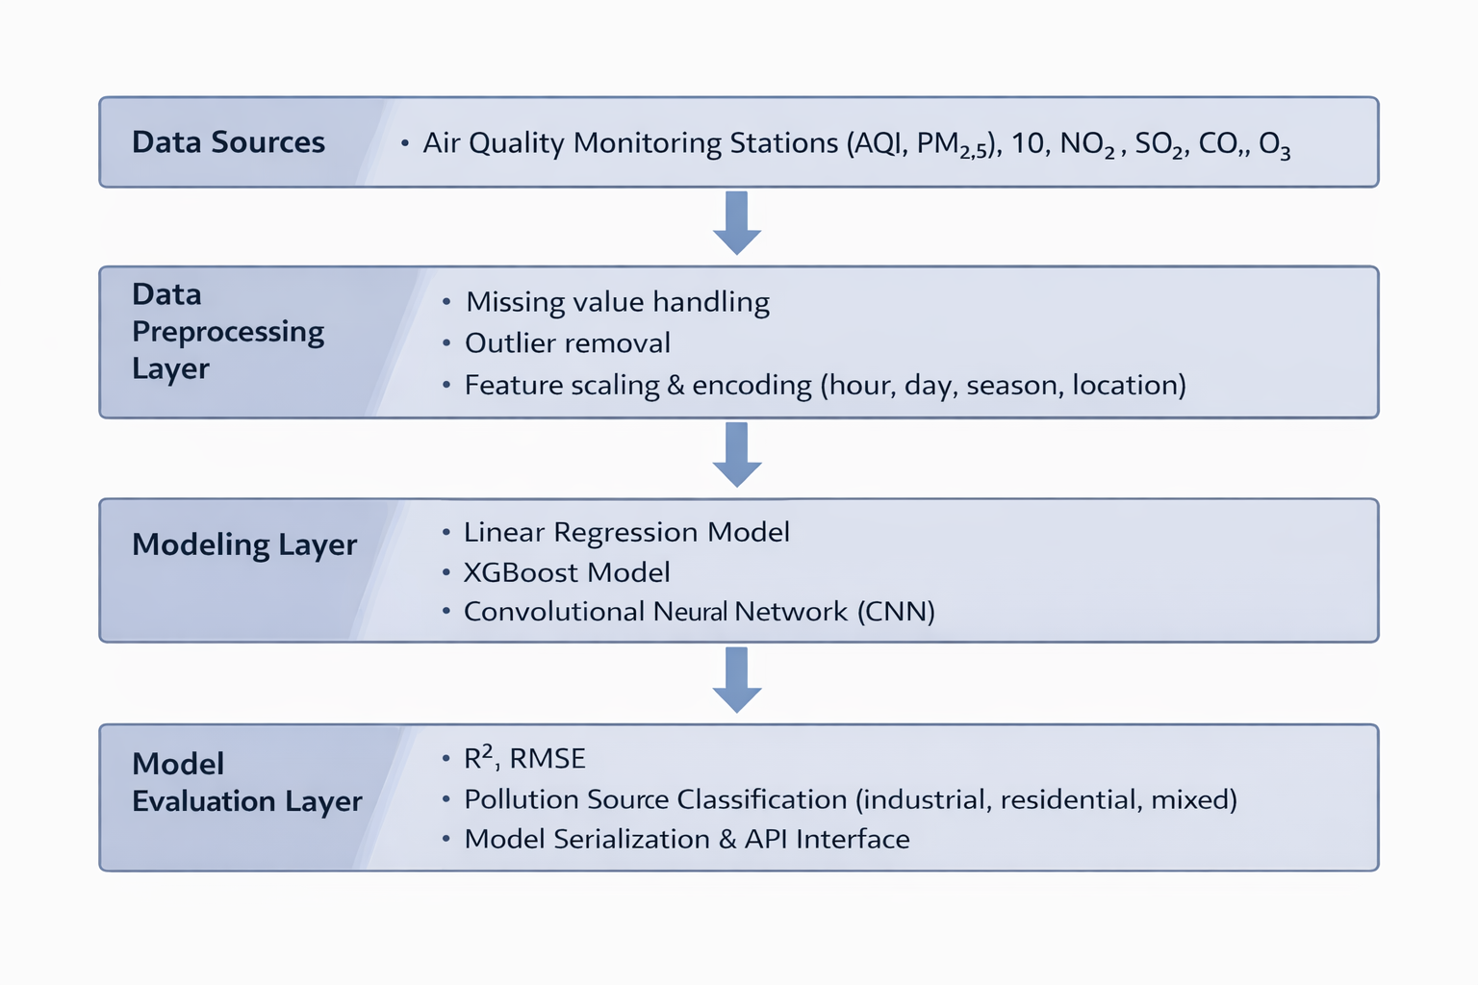
High Level Architecture Diagram
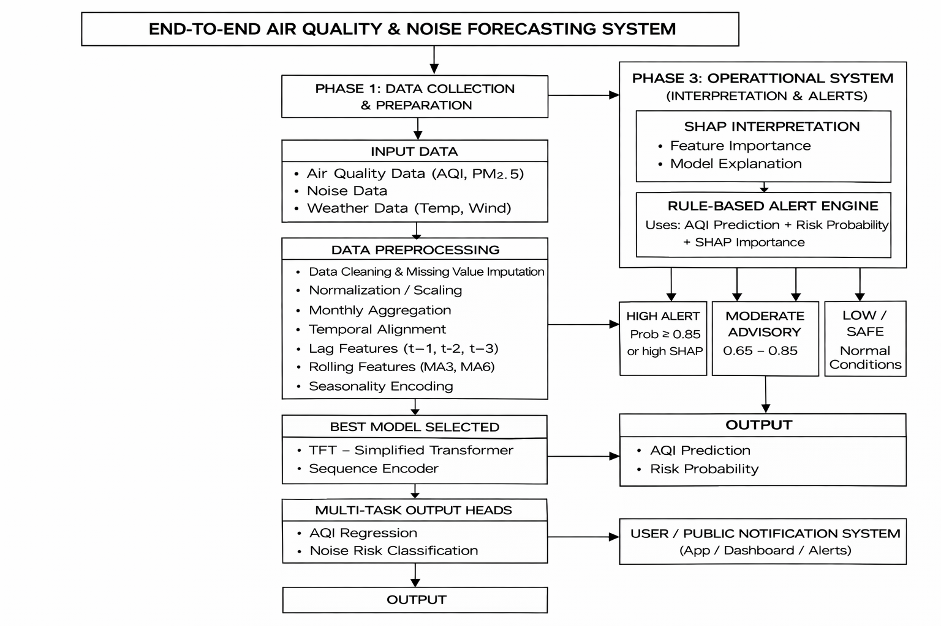

Frequency of data exchange
Air quality and meteorological data are exchanged at daily to hourly intervals, noise pollution data at monthly intervals, and prediction requests are processed on-demand through a real-time API, reflecting the heterogeneous temporal resolution of urban environmental data.

Datasets
AQI Dataset links:- https://www.kaggle.com/datasets/rohanrao/air-quality-data-in-india
Noise Dataset link:-https://www.kaggle.com/datasets/rohanrao/noise-monitoring-data-in-india

